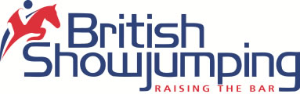 North Cumbria Area 14

Area Show
Only eight days to go to the first Area show of the year! We are pleased to advise that we have been allocated qualifiers for the Game Fair.
The Game Fair, which is Britain’s largest and most prestigious countryside event, have announced a series of qualifiers to be run on grass at equestrian centres and premiere county and agricultural shows around the country. First round qualifying competitions for Connolly’s RED MILLS Senior Newcomer and Equitop Myoplast Senior Foxhunter are to be held at:
- South Suffolk Show – 14th May
- British Showjumping North Cumbria Area Show – 14th May classes 7 and 8.
- Rockingham International Horse Show – 20th May
- Fife Agricultural Show – 20th May
- Herts Country Show – 27th – 28th May
- British Showjumping North Yorkshire Area Show at Allerton Park – 28th May
- Wivelsden - 29th May
- Northumberland County Show – 29th May
- Royal Bath and West Show - 2nd June
- Rutland Show – 4th June
- South West Showjumping Club at Chard Equestrian Centre – 15th – 18th June
- Royal Three Counties Show – 16th – 18th June
- Wales and West Shows - 17th June
- Wivelsden - 18th June
- North Yorkshire County Show– 18th June
- Llanddarog Show – 24th June
- Bicton Arena, Devon – 24th – 25th June
- Derbyshire County Show at Locko Park – 25th June
- Royal Norfolk Show - Foxhunter only 28th – 29th June
- Lanchester Show – 2nd July
- Ashby de la Zouch Show – 9th July
- Chard Equestrian Ltd – 7th – 9th July
The top six placing and all double clears will qualifying for this prestigious Championship finals held at the Game Fair between 29th – 30th July 2017 at Hatfield House, Hertfordshire.
For more information about The Game Fair 2017 please click here.

Turnout Equestrian Supplies from Maryport will be at the show with their trade stand catering for all of your equestrian needs with brands including Mountain Horse, Toggi. Lemieux and much more. If there is anything you need please call and see Kris and he will be only too happy to help.
Don’t forget to take advantage of this amazing offer from our very generous sponsors of the National 1.40m Edgemere Ltd.
Please visit www.edgemere.co.uk and enter code BSAREA14 to receive 25% off all footwear!

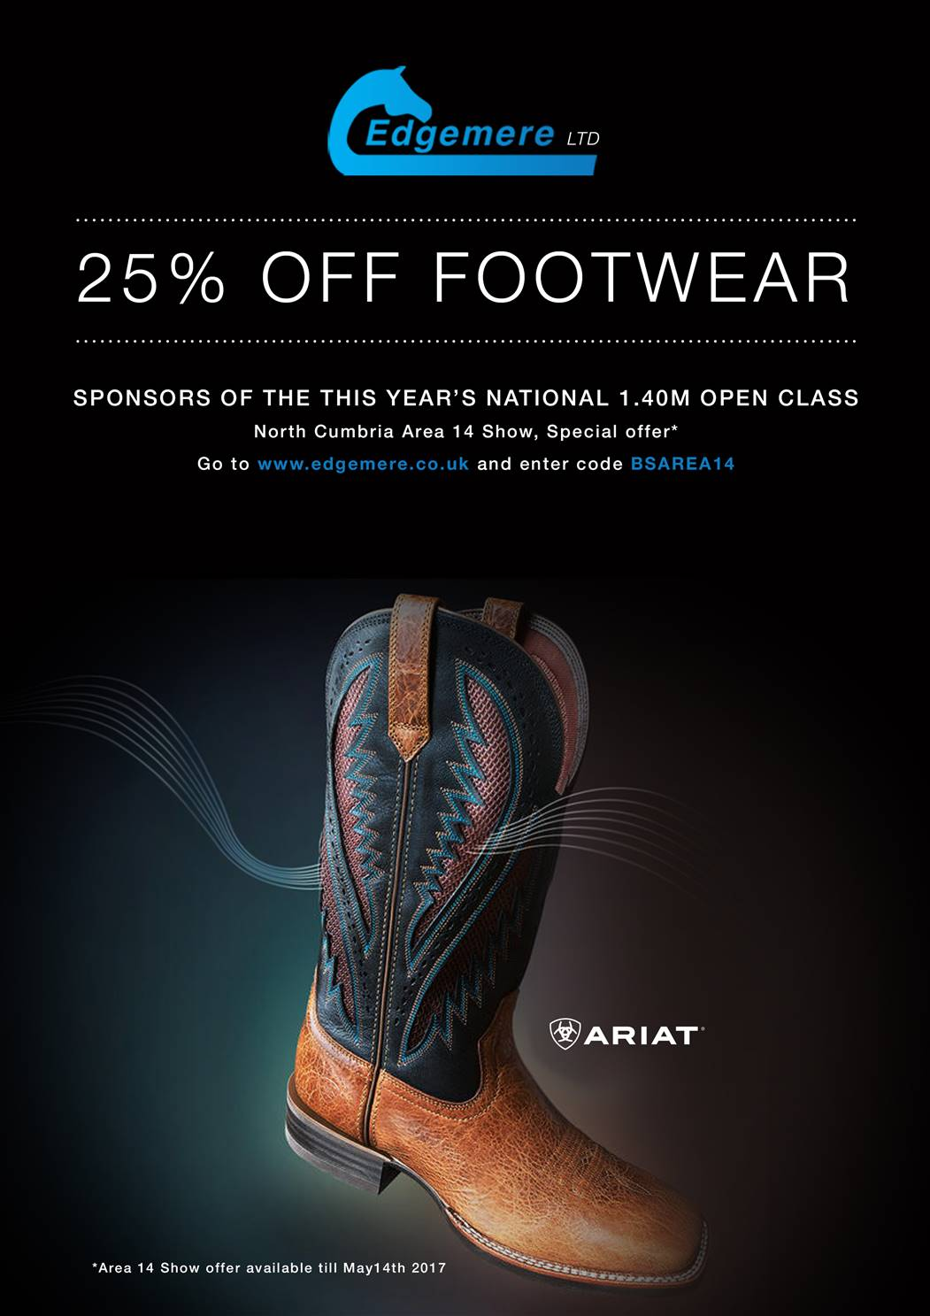

Digital Works Photography
Digital Works Photography will be there for the weekend taking photographs. Please visit their website http://digitalworksltd.co.uk/ to purchase photos.
Please can we ask that no pictures are posted on face book etc without being purchased from Digital Works Photography!

Area Points
Area points will be allocated in the same format as last year and will run from 1st January 2017 – 31st December 2017.

1/ Points will be awarded at every area show (indoors and outdoors) and also any other BS show in the area regardless of the schedule.

2/ Points will be awarded to Area 14 and Area 14a members only.

3/ Points will be awarded 1st-5th place regardless of prize money placing as long as the horse/pony rider combination jump clear in the first round.

4/ Points will be allocated as follows
1st 10 points
2nd 8 points
3rd 6 points
4th 4 points
5th 2 points

5/ For those placed equal first on points at the end of the season they will be joint Champions and prizes will be awarded to both combinations.

This year we will also have two new awards which will be for the Senior 90cm and 1.00m opens.

Area Training
There are still a few slots available for training with Robert Shields on Thursday 18th May on the Area Show Field.
Training is again open to Juniors and seniors and costs £30.00 for ½ hour private lesson. There is an additional £5.00 charge for non BS members. Bookings can be made via the Horse Monkey Website.
Unfortunately refunds can only be given if the space can be filled

Junior Academy
The next junior academy will be held on Friday 2nd June at Greenlands Equestrian Centre, Wreay. The day will include flat work and jumping lessons, balance session, fitness and pilates, horse physio and much more! The cost is £45.00 for the day and to book please contact Michelle Clough 07584 706459or email michelle.clough@britishshowjumping.co.uk
Also if anyone wants to order a jacket or gilet prices start at £20 and can again be ordered through Michelle.

Show Sponsors
Thank you to the following companies who are very kindly sponsoring at our two-day area show in May. If you would like to sponsor, please contact any committee member or call the area phone on 07468 111787.



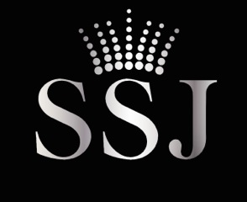

Douglas Duffin


Frame, Swift & Partners

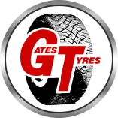
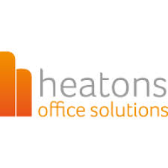

www.britishshowjumping.co.uk/area/North-Cumbria
Don’t forget to check out our area face book page Area 14 North Cumbria British Show jumping

